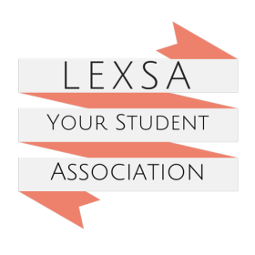
FIRST AID COURSE
PAYMENT & REFUND POLICY

- All current LEXSA members are eligible to register to attend a subsidised LEXSA organised First Aid Course, these are advertised when the Course becomes available.

- Payment is at time of sign up for First Aid Course, sign up closes four days before course is due to be held.

- Refunds or First Aid Course date transfers will only be given if a written request is received at LEXSA Office or by email lexsa@scu.edu.au four days before course is due to be held.

- For exceptional circumstances where you are not able to contact LEXSA four days prior, each case will be looked at on individual merit.

